**Liberty University**

**CSIS 331**

**Lab 7 Answer Sheet**

Complete the table.

|  |  |  |
| --- | --- | --- |
| **Device** | **IPv4 Address** | **IPv4 Subnet Mask** |
| R1 G0/0 | 192.168.0.1 | 255.255.255.128 |
| R1 G0/1 | 192.168.0.129 | 255.255.255.192 |
| R1 G0/2 | 192.168.0.193 | 255.255.255.224 |
| **Device** | **IPv4 Address** | **IPv4 Subnet Mask** | **IPv4 Default Gateway** |
| S1 Vlan 1 | 192.168.0.2 | 255.255.255.128 | 192.168.0.1 |
| S2 Vlan 1 | 192.168.0.130 | 255.255.255.192 | 192.168.0.129 |
| S3 Vlan 1 | 192.168.0.1 | 255.255.255.224 | 192.168.0.193 |
| Staff NIC | 192.168.0.126 | 255.255.255.128 | 192.168.0.1 |
| Sales NIC | 192.168.0.190 | 255.255.255.192 | 192.168.0.129 |
| IT NIC | 192.168.0.222 | 255.255.255.224 | 192.168.0.193 |

Copy and Paste Screenshot of Browser showing [www.cisco.pka](http://www.cisco.pka) from Staff, Sales and IT:

1)Staff

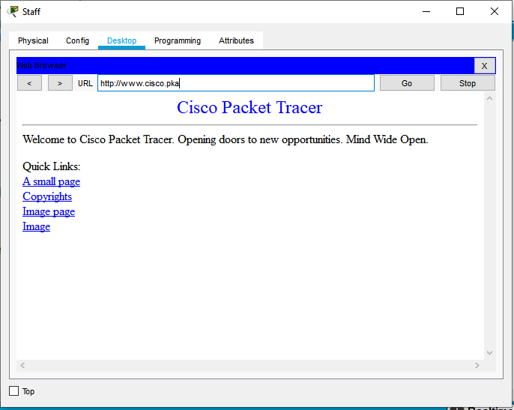

2)Sales

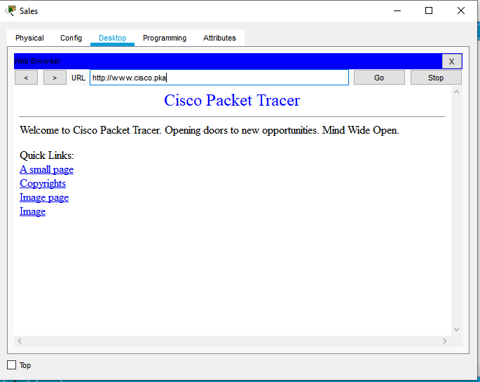

3)IT

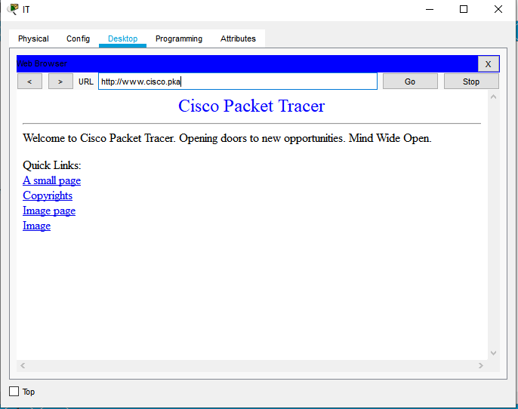

Copy and Paste Screenshot of Browser showing [www.cisco6.pka](http://www.cisco6.pka) from Staff, Sales and IT:

1)Staff

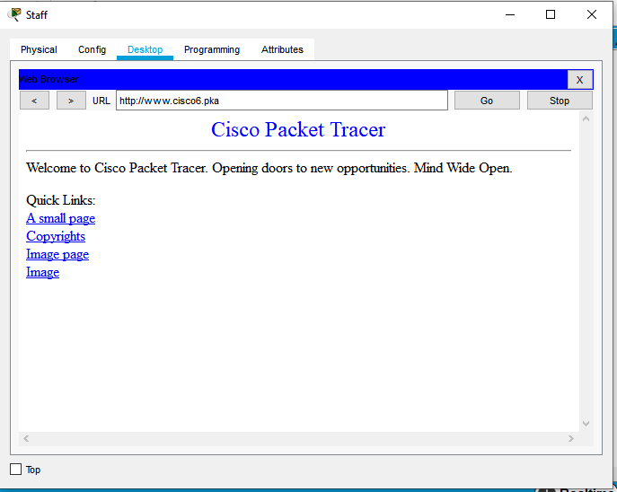

2)Sales

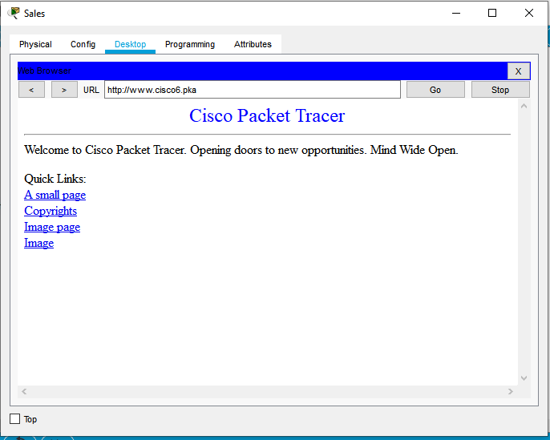

3)IT

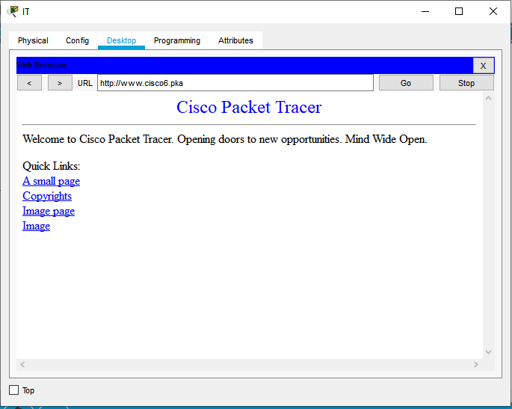

Ping Output IPv4:

|  |  |  |  |
| --- | --- | --- | --- |
| **Ping From Device IPv4** | **Ping to Device IP** | **Results** | **How did you resolve any errors?** |
| Staff | Sales | C:\>ping 192.168.0.190  Pinging 192.168.0.190 with 32 bytes of data:  Reply from 192.168.0.190: bytes=32 time=1ms TTL=127  Reply from 192.168.0.190: bytes=32 time=14ms TTL=127  Reply from 192.168.0.190: bytes=32 time=13ms TTL=127  Reply from 192.168.0.190: bytes=32 time=3ms TTL=127  Ping statistics for 192.168.0.190:  Packets: Sent = 4, Received = 4, Lost = 0 (0% loss),  Approximate round trip times in milli-seconds:  Minimum = 1ms, Maximum = 14ms, Average = 7ms |  |
| Staff | IT | C:\>ping 192.168.0.222  Pinging 192.168.0.222 with 32 bytes of data:  Reply from 192.168.0.222: bytes=32 time=1ms TTL=127  Reply from 192.168.0.222: bytes=32 time=12ms TTL=127  Reply from 192.168.0.222: bytes=32 time=13ms TTL=127  Reply from 192.168.0.222: bytes=32 time=13ms TTL=127  Ping statistics for 192.168.0.222:  Packets: Sent = 4, Received = 4, Lost = 0 (0% loss),  Approximate round trip times in milli-seconds:  Minimum = 1ms, Maximum = 13ms, Average = 9ms |  |
| Staff | Web | C:\>ping 64.100.0.3  Pinging 64.100.0.3 with 32 bytes of data:  Reply from 64.100.0.3: bytes=32 time=4ms TTL=125  Reply from 64.100.0.3: bytes=32 time=10ms TTL=125  Reply from 64.100.0.3: bytes=32 time=12ms TTL=125  Reply from 64.100.0.3: bytes=32 time=15ms TTL=125  Ping statistics for 64.100.0.3:  Packets: Sent = 4, Received = 4, Lost = 0 (0% loss),  Approximate round trip times in milli-seconds:  Minimum = 4ms, Maximum = 15ms, Average = 10ms |  |
| Sales | IT | C:\>ping 192.168.0.222  Pinging 192.168.0.222 with 32 bytes of data:  Reply from 192.168.0.222: bytes=32 time=2ms TTL=127  Reply from 192.168.0.222: bytes=32 time=14ms TTL=127  Reply from 192.168.0.222: bytes=32 time<1ms TTL=127  Reply from 192.168.0.222: bytes=32 time=3ms TTL=127  Ping statistics for 192.168.0.222:  Packets: Sent = 4, Received = 4, Lost = 0 (0% loss),  Approximate round trip times in milli-seconds:  Minimum = 0ms, Maximum = 14ms, Average = 4ms |  |
| Sales | Web | C:\>ping 64.100.0.3  Pinging 64.100.0.3 with 32 bytes of data:  Reply from 64.100.0.3: bytes=32 time=2ms TTL=125  Reply from 64.100.0.3: bytes=32 time=16ms TTL=125  Reply from 64.100.0.3: bytes=32 time=36ms TTL=125  Reply from 64.100.0.3: bytes=32 time=12ms TTL=125  Ping statistics for 64.100.0.3:  Packets: Sent = 4, Received = 4, Lost = 0 (0% loss),  Approximate round trip times in milli-seconds:  Minimum = 2ms, Maximum = 36ms, Average = 16ms |  |
| IT | Web | C:\>ping 64.100.0.3  Pinging 64.100.0.3 with 32 bytes of data:  Reply from 64.100.0.3: bytes=32 time=3ms TTL=125  Reply from 64.100.0.3: bytes=32 time=11ms TTL=125  Reply from 64.100.0.3: bytes=32 time=23ms TTL=125  Reply from 64.100.0.3: bytes=32 time=14ms TTL=125  Ping statistics for 64.100.0.3:  Packets: Sent = 4, Received = 4, Lost = 0 (0% loss),  Approximate round trip times in milli-seconds:  Minimum = 3ms, Maximum = 23ms, Average = 12ms |  |

Ping Output IPv6:

|  |  |  |  |
| --- | --- | --- | --- |
| **Ping From Device IPv6** | **Ping to Device IP** | **Results** | **How did you resolve any errors?** |
| Staff | Sales | C:\>ping 2001:DB8:ACAD:1::2  Pinging 2001:DB8:ACAD:1::2 with 32 bytes of data:  Reply from 2001:DB8:ACAD:1::2: bytes=32 time=1ms TTL=127  Reply from 2001:DB8:ACAD:1::2: bytes=32 time=11ms TTL=127  Reply from 2001:DB8:ACAD:1::2: bytes=32 time=3ms TTL=127  Reply from 2001:DB8:ACAD:1::2: bytes=32 time=12ms TTL=127  Ping statistics for 2001:DB8:ACAD:1::2:  Packets: Sent = 4, Received = 4, Lost = 0 (0% loss),  Approximate round trip times in milli-seconds:  Minimum = 1ms, Maximum = 12ms, Average = 6ms |  |
| Staff | IT | C:\>ping 2001:DB8:ACAD:2::2  Pinging 2001:DB8:ACAD:2::2 with 32 bytes of data:  Reply from 2001:DB8:ACAD:2::2: bytes=32 time=1ms TTL=127  Reply from 2001:DB8:ACAD:2::2: bytes=32 time=11ms TTL=127  Reply from 2001:DB8:ACAD:2::2: bytes=32 time=13ms TTL=127  Reply from 2001:DB8:ACAD:2::2: bytes=32 time=11ms TTL=127  Ping statistics for 2001:DB8:ACAD:2::2:  Packets: Sent = 4, Received = 4, Lost = 0 (0% loss),  Approximate round trip times in milli-seconds:  Minimum = 1ms, Maximum = 13ms, Average = 9ms |  |
| Staff | Web | C:\>ping 2001:DB8:CAFE::3  Pinging 2001:DB8:CAFE::3 with 32 bytes of data:  Reply from 2001:DB8:CAFE::3: bytes=32 time=2ms TTL=125  Reply from 2001:DB8:CAFE::3: bytes=32 time=15ms TTL=125  Reply from 2001:DB8:CAFE::3: bytes=32 time=14ms TTL=125  Reply from 2001:DB8:CAFE::3: bytes=32 time=15ms TTL=125  Ping statistics for 2001:DB8:CAFE::3:  Packets: Sent = 4, Received = 4, Lost = 0 (0% loss),  Approximate round trip times in milli-seconds:  Minimum = 2ms, Maximum = 15ms, Average = 11ms |  |
| Sales | IT | C:\>ping 2001:DB8:ACAD:2::2  Pinging 2001:DB8:ACAD:2::2 with 32 bytes of data:  Reply from 2001:DB8:ACAD:2::2: bytes=32 time<1ms TTL=127  Reply from 2001:DB8:ACAD:2::2: bytes=32 time=14ms TTL=127  Reply from 2001:DB8:ACAD:2::2: bytes=32 time=3ms TTL=127  Reply from 2001:DB8:ACAD:2::2: bytes=32 time=3ms TTL=127  Ping statistics for 2001:DB8:ACAD:2::2:  Packets: Sent = 4, Received = 4, Lost = 0 (0% loss),  Approximate round trip times in milli-seconds:  Minimum = 0ms, Maximum = 14ms, Average = 5ms |  |
| Sales | web | C:\>ping 2001:DB8:CAFE::3  Pinging 2001:DB8:CAFE::3 with 32 bytes of data:  Reply from 2001:DB8:CAFE::3: bytes=32 time=2ms TTL=125  Reply from 2001:DB8:CAFE::3: bytes=32 time=12ms TTL=125  Reply from 2001:DB8:CAFE::3: bytes=32 time=3ms TTL=125  Reply from 2001:DB8:CAFE::3: bytes=32 time=15ms TTL=125  Ping statistics for 2001:DB8:CAFE::3:  Packets: Sent = 4, Received = 4, Lost = 0 (0% loss),  Approximate round trip times in milli-seconds:  Minimum = 2ms, Maximum = 15ms, Average = 8ms |  |
| IT | Web | C:\>ping 2001:DB8:CAFE::3  Pinging 2001:DB8:CAFE::3 with 32 bytes of data:  Reply from 2001:DB8:CAFE::3: bytes=32 time=3ms TTL=125  Reply from 2001:DB8:CAFE::3: bytes=32 time=12ms TTL=125  Reply from 2001:DB8:CAFE::3: bytes=32 time=12ms TTL=125  Reply from 2001:DB8:CAFE::3: bytes=32 time=17ms TTL=125  Ping statistics for 2001:DB8:CAFE::3:  Packets: Sent = 4, Received = 4, Lost = 0 (0% loss),  Approximate round trip times in milli-seconds:  Minimum = 3ms, Maximum = 17ms, Average = 11ms |  |